First, what exactly is “Full Stack” Development?
- Think of a webpage (front end), which communicates with a server (backend), to store and change data in a database. That’s a basic idea of how lots of web apps work.
  - A Full Stack Developer can create all of these components and make them work together to develop one full stack application. A full stack app is essentially a “stack” of technologies.
    - (...Basically. I’m keeping it simple for now.)
- We’ll learn how these components work together over the next few months and build our own full stack apps with various powerful tools. We’ll start with Java, which is a primarily back end language. (Thus, server-side).
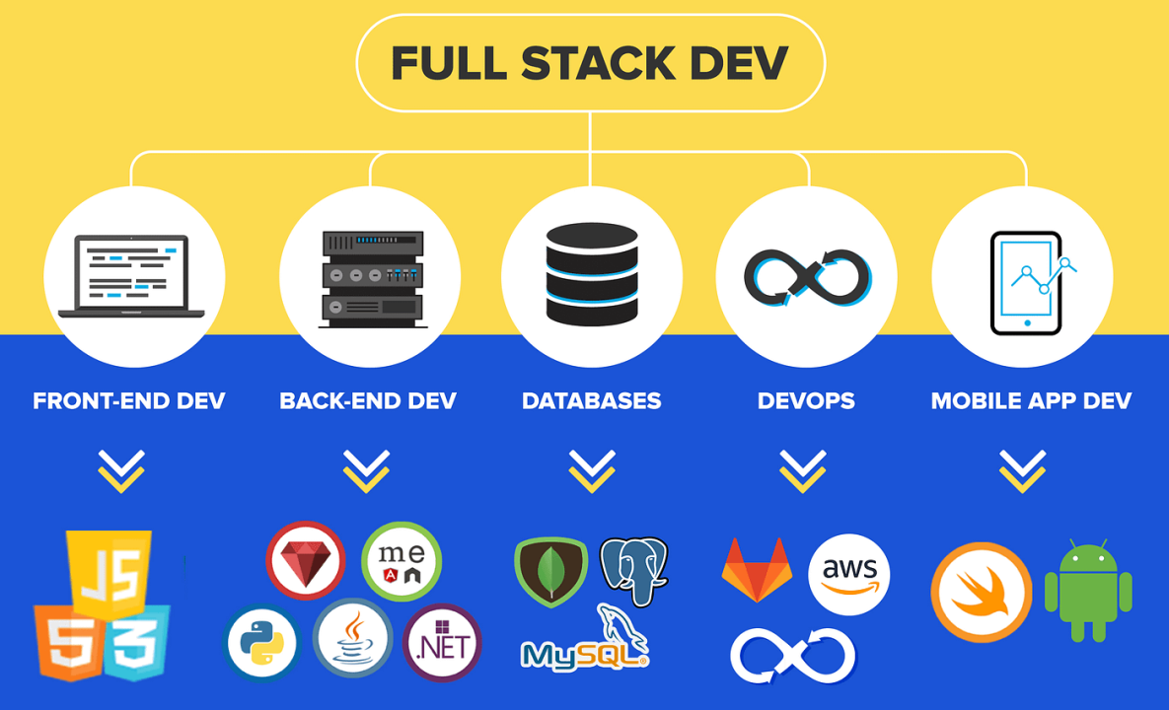

What is a Programming Language?
- “A tool that creates a set of instructions to tell a computer what to do”. “A way to communicate with a computer”.
  - Set of instructions -> gets turned into binary code for a computer to read.
    - Compilation – Java gets compiled into bytecode, which gets compiled into binary code. More on this later.
      - The compiler is essentially a translator from human readable code to computer readable instructions.
- Programming Languages basically consist of:
  - Syntax - what the language looks like. The verbs/nouns (keywords) used etc.
    - Java syntax: int i = 500;
  - Data types - the different mechanisms of data storage. (Integer? Decimal? Text? …Plus many many more)

Low Level vs High Level Programming Languages
- Rule of thumb: the lower level a programming language is, the less human readable it is. Thus, high level languages are considered more human readable.
- Machine Language - This is basically binary code. Very low level.
- Assembly Language - Low level language that is specific to a machine but also /somewhat/ human readable
  - Line 1: Get first number
  - Line 2: get second number
  - Line 3: Add the numbers together
  - Line 4: Access memory location to store this result
  - Line 5: Finally store the result in memory
- High Level Languages (Java/Python/C++)
  - These are written for human programmers to be able to read and write instructions easily on a computer.
    - In Java, the above assembly language task is as simple as:
      - int i = a + b;

So… What is Java?
- It is a high-level programming language. (That means it’s more human readable)
- Highly Object Oriented - relies heavily on objects, which we’ll talk about later.
  - Not completely OOP (object-oriented programming) because it still does have “primitive” values that are not objects (e.g. int, char, boolean)
  - There are 4 Pillars of OOP (we will go into great detail later)
    - Abstraction
    - Encapsulation
    - Inheritance
    - Polymorphism
- Java is Strongly typed
  - Every variable must be declared with its data type. Java won’t assume a variable’s datatype.
    - a = 5; -> WRONG AND BAD
    - int a = 5; -> right and good :)
- Java is Strictly typed
  - Variables, once declared, cannot change their data type easily. (They CAN change their data type, but with extra steps.)
  - 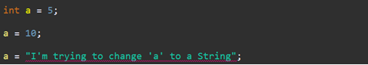

Advantages of Java
- Automatic Memory Management - memory is allocated under the hood, which means we never have to worry about it. You don’t have to tell Java where to store things.
- Write Once Run Anywhere - Java applications can run on any machine with a Java Runtime Environment (JRE).
- Widely used, quite powerful, a lot of debugging help on forums online. Plus AI hallucinates less with Java than something more niche.
  - “Powerful”? All programming languages can basically do the same things, but Java is powerful in that it can do much more complex stuff in easier ways. So we can consider Java more powerful than binary code for instance.
- Extensive Libraries and Frameworks that are open source (free to use)

Disadvantages of Java
- Automatic Memory Management - Can be inefficient in some environments if you NEED access to the memory for some reason.
- Java apps generally require the JRE in order to run.
- Strong/Strict typing can be a disadvantage, since there are more rules to your code.
  - (I personally like it though, it makes code more readable to me).
- Essentially forces Object Oriented Programming, which can slow down development.
- Compiled into computer-readable byte-code, so it takes time to “build” your project from the source (what we write), to byte code (which the computer reads)

*How to create a new project with a main method in IntelliJ:
-First, I recommend making a folder to hold your personal demos/projects.
-Try to avoid spaces in your naming! It can cause issues with some tools we’ll use.
-Open Intellij
-File -> New -> Project
-On the left bar, make sure to set it to Java if it’s not already
-For our first app, we’ll put “HelloWorld” for the project name. Make sure you choose the folder that you want your application to be in, and that you’ve selected the appropriate Java version before hitting “Create”. (We’ll be using the built-in Temurin 21)
-right click src -> new package called com.revature
-right click com.revature -> new Class called Main
-make a main method inside Main to write your code in
How Java Works: JDK/JRE/JVM
- These three things go hand in hand to let us write and run Java applications.
- JDK - Java Development Kit => Everything you need to write/compile Java code
  - Compiler - Turns Java code into bytecode for machines to read
  - Dev Tools - Tools specific for developers writing code
  - Debugger - Help with debugging issues by indicating problems
  - Documentation tools
  - Contains the JRE:
- JRE - Java Runtime Environment => Everything needed to actually run a Java application
  - Look at the name - it’s the runtime environment for Java apps. Java apps need this to run!
  - Contains built-in Java Class libraries which give our application many popular and powerful features
  - Contains the Class Loader which helps with loads classes in the JVM:
    - Contains the JVM*
- JVM - Java Virtual Machine => Actually runs your code, in a virtual environment that behaves the same across devices.
  - JIT (Just-In-Time) compiler => When your application starts running, the JIT turns bytecode into machine code, essentially line by line as it runs, feeding your machine instructions.
    - This is different from the “main” compiler in the JDK that turns Java into bytecode
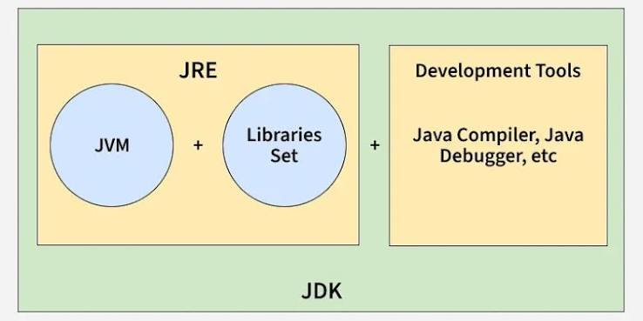
Java Development Kit (JDK): Contains everything to write/compile java
Java Runtime Environment (JRE): Contains resources to run java application
Java Virtual Machine (JVM): What java actually runs on

Java Variables
- Variables hold values that we use in our code.
  - Like an int that holds the number 5, or a String that holds the text “Hello World!”
- A variable’s data can be accessed and changed, or the variable can be reassigned to hold completely new data.
  - Also, you don’t always need to provide a value to a variable you declare.
- There are 2 types of variables in Java: Primitives and Reference Variables.
  - Primitives hold simple values like the number 5.
  - Reference variables hold a reference to an Object. Technically it “refers” to the location in memory where an object is stored (AKA the memory address).
    - For now, just think of objects as more complex types of variables. They can store multiple values AND behaviors.

- Java has 8 primitives. These are the ONLY things in Java that aren’t Object Oriented (because primitives are not objects!!!!!)
  - boolean, byte, short, char, int, long, double, float
Primitive Type | Size | Description
*boolean | 1 bit | Represents True/False
byte | 1 byte | Signed numerical value from -128 to 127
short | 2 bytes | Signed numerical value from -32,678 to 32,767
*int | 4 bytes | Most commonly used signed numerical value from -2147483648 to 2147483647
long (Identified with an“L”) Eg: long num = 12000000000000000L; | 8 bytes | BIG signed numerical value
*double | 8 bytes | Signed floating point number. Most common (and default) decimal.
float (Identified with an “f”)  Eg: float num = 120.5f; | 4 bytes | Another signed floating number.
char (as in ‘character’) | 2 bytes | Unicode value  Unicode is a universal character encoding standard that assigns a code to every character and symbol in every language in the world
*Why use short/byte over int when int has so many more numbers? Memory. Imagine you need to store 2 billion small numbers. I’d rather take up 75% less memory with a byte than using 4 bytes with an int. Same story with float vs double.

- Quick notes on type coercion:
  - We can convert larger data types into smaller data types easily.
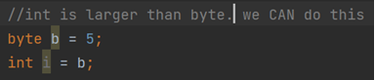
  - However, we cannot implicitly convert smaller data types into larger ones.
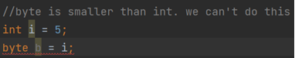
  - Converting an integer type to a decimal type will add decimal places
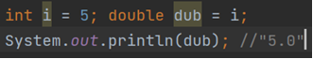
  - And decimal places get lost when converting from decimal types to integer types. (It rounds down)
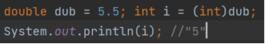
- Notice the explicit (int) conversion that we have to do due to the datatype’s difference in size. This is called type casting.

Arithmetic Operators

- Arithmetic Operators are used to perform basic mathematical operations
  - +
  - -
  - *
  - /
  - % (modulus, returns the remainder)
  - ++ (increment a value by one)
  - -- (decrement a value by one)

Control Flow
- Control flow is the logical progression of your application at runtime.
  - In other words, it’s the order in which your code executes at runtime.
  - Generally, code executes from top to bottom. But sometimes, you have to make decisions on what code executes when.
- We can use simple logical statements to determine how our application will branch, loop, and progress based on what is present at the application run time.
  - Control flow statements include: if statement, while loop, do-while loop, for loop, (enhanced for loop), and switch statements

If statement

- conditional yes/no statement. If the condition is true, the code runs. Otherwise, it does not.
  - You can specify alternate code to run if the “if statement” does not (else)
  - You can also write the statement to check multiple conditions (else if)
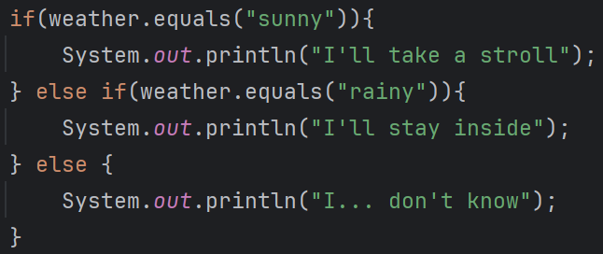

While loop

- evaluates a boolean, and runs the block of code if the boolean is true. It loops over and over until the boolean is false.
  - There’s also the Do-while loop, which runs the block of code once, and THEN operates like a normal while loop, evaluating a boolean and running the code until it is false. (not pictured, we’ll see it in a demo though)
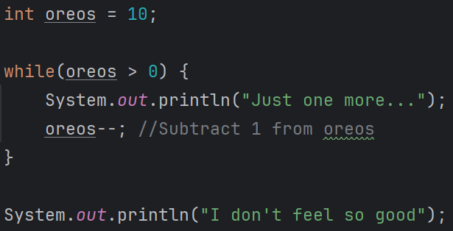

For loop

- Used for iteration, which means moving through a sequence of data one by one. It allows us to set up behavior that loops “X amount of times”.

- For loops contain three parts:
  - Declaration - creates a variable in the block’s scope that runs once at the beginning of the for loop.
  - Condition - a statement that resolves to a boolean, check each time the loop runs.
  - Statement - a set of code that runs at the end of the block every time the block runs. (Generally used for incrementing or decrementing).

You can set the amount of loops when creating the loop
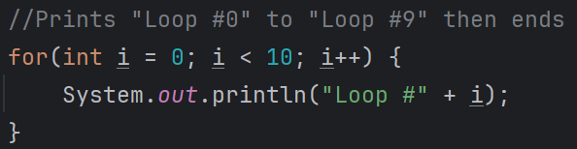

OR you can loop through a sequence like an Array
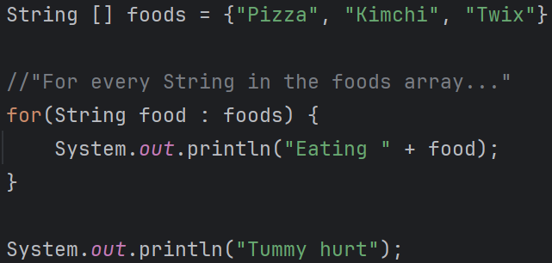
- While loop vs for loop use cases?
  - You’ll use a for loop when you know how many times you want the loop to run.
  - You’ll use a while loop when you don’t have a specific amount of loops you want.

Switch statement

- Evaluates a variable, and tests it against “cases”. The first case that it matches will run the specified code and continue to run down the statement until it reaches a break statement, or the switch statement ends.
  - You can also have a “default” case, which will run in the event of none of the cases matching the value of your tester variable
These fill a role similar to if statements, but they scale more gracefully
(50 cases is cleaner than 50 “if”s)
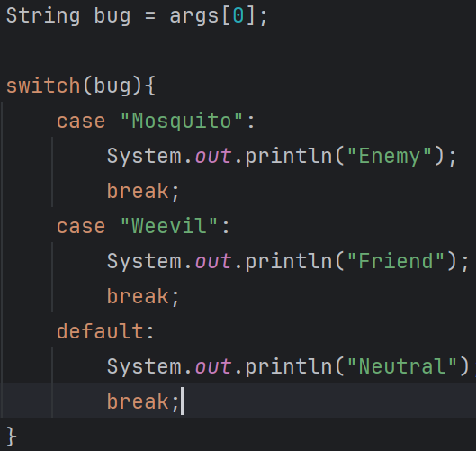

- Break and Continue
  - In loops or blocks, we can either exit the loop/block entirely, or skip to the next iteration.
  - Break will exit a loop/switch statement/block entirely. These are necessary in each case of a switch statement, or else every case will execute.
  - Continue will stop the current iteration and proceed to the statement (if it’s a for loop) or evaluation (if it’s a while loop) for the next loop.
    - In English, continue simply skips the current loop, and goes on to the next one. So it’ll stop whatever is happening in the current loop and CONTINUE looping.
- Most control flow statements are based on boolean expressions. There are convenient symbols to use for boolean evaluations in Java
  - “==” Checks equality (generally used for primitives). For reference variables it compares memory addresses, not the values of the objects. (Not as useful)
    - 5 == 5 //true
  - “!=” Checks for inequality between primitives
    - 5 != 6 //true
    - “!” reverses a boolean. Think of it like “not”. != means “is not equal to”.
  - “>, <, >=, <=”: Standard mathematical symbols for comparison.
  - “&&”: Return true only if the boolean expressions on either side are both true.
    - Think of it like “and”
  - “||”: Returns true if either expression is true.
    - Think of it like “or”
  - “^” (xor): exclusively or, only returns true if one of the values is true and the other is false.
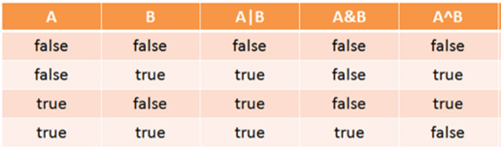
Quick reference to how |, &, and ^ behave with different true/false values for two booleans

Arrays
- Arrays in Java are objects that store the same type of data, sequentially.
  - So it’s like a list of data, but we’ll see why “list” isn’t a great word for Java Arrays.
- Arrays are fixed length (The Array Class has a length field which is final).
  - If you need a larger/smaller Array, you have to create a new Array object in memory
  - You can access the length of an array as a field variable. E.g. myArray.length
    - *Note this is not a method! It’s a variable. It’s not .length(), it’s .length
- Each element in an Array has a specific index. This allows you to quickly find a single value in an Array. The first index of an Array is 0. In other words, Arrays are zero-indexed.
“Java Arrays are zero-indexed objects that store elements of the same data type sequentially. They are immutable in size which means their size can’t be changed.”

- You can change the values in Array as long as they’re of the same type.

- There are 2 ways to define an Array:
  - 1) Assign values when you initialize the Array
    - int[] intArray = {8, 9, 10};
  - 2) Initialize an empty Array of the length you need, then fill them by index later
    - int[] intArray = new int[3];
- https://docs.oracle.com/javase/7/docs/api/java/util/Arrays.html

Java Application Structure
- You’ll find that all Java apps are comprised of Classes (which have fields and methods) that are organized into Packages. Let’s dissect these terms:
Java Classes
- The best way to think of a class is as a template or a blueprint for an object (read more about objects below). A Class defines data and functionalities. We then create objects based on that Class so we can use its data and functionalities in our code.
  - Creating a Class is like creating a new datatype that you can use in your code.

- Classes contain fields (aka variables/data) and methods (aka behaviors/functionality)
  - Fields are variables that store data about the Class
  - Methods are blocks of code that represent actions the Class can take.
    - Think of fields like attributes, and methods like behaviors
    - The fields and methods of a class are also known as its members

Here’s a super basic Class with 2 fields and 1 method
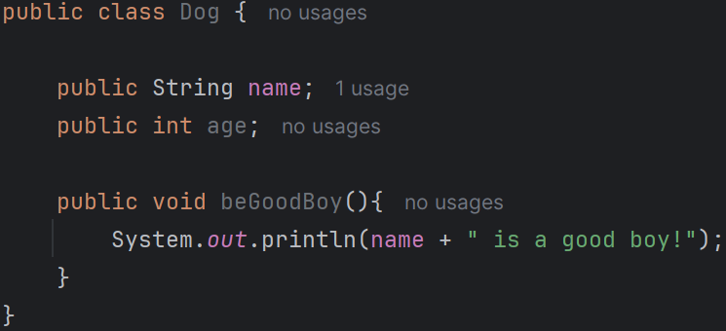
- Best practice for naming Classes is to use upper-case CamelCase (AKA PascalCase)
  - E.g. ThisIsMyClassName
- A class can extend another class with the “extends” keyword, thus inheriting that class’s traits. More on inheritance later.

Java Methods
We saw an example above. Here’s another Method signature you may recognize:
Here’s another one that takes in two numbers and returns their sum:
- Methods define the behaviors of a class/object. Things the class/object can do.
- “A Method is a block of code defined in a Class that can be invoked (used) multiple times. They are essentially actions or behaviors that an object can take”.
  - Methods are often used to save or manipulate information, or convey a message. But really it’s hard to pin down what a method does because you can make a method do just about anything.
- Methods (and variables) have access modifiers, which determine the visibility of the method/variables to outside classes.
  - private - only visible to the class itself.
  - default - only accessible within the package (we don’t specify any access modifier if we want default).
  - protected - accessible to anything within the same package plus any subclasses of the owning class.
  - public - accessible to any class in the project/application.

- Methods and variables can have non-access modifiers as well. These are declared in the method signature after the access modifier.
  - Non-access modifiers include static, final, and abstract. We’ll see them later.
- Methods have a return type, which states what the method “gives back” when it’s called.
  - Return types can be primitive values, objects, or nothing at all (void)
    - What do the 3 methods above return?
- Methods can take parameters, but they don’t have to. Parameters are the variable values that a method uses to operate.
  - Parameters are listed inside the parentheses after the method name. They can be objects or primitives, and the method will have to access them by the names of their variables.
- Main Method anatomy
  - [Access modifier] [Non-access modifier] [Return Type] [Name] (parameters){}
  - public static void main (String[] args)

Java Packages
- Like any file folder, they store and organize our Java files (Classes)
  - Packages will generally be sorted into areas of functionality for our program
- Package declarations (declaring where the .java file is located) must be the first line in a java file, except for comments

- Package naming convention is generally lowercase with “.” indicating nested packages.
  - We typically create the default com.revature package where we store our Main method class. But we’ll eventually have packages with names like com.revature.models, or com.revature.controllers. We’ll get there soon.
- Sample src folder structure:
  - src folder
    - Organization type package (com because Revature is a company)
      - Group package (revature because we’re Revature)
        - App package (the specific use of the package)
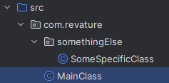//Note that we can nest packages! Very common.
//We have MainClass in com.revature, and SomeSpecificClass in com.revature.somethingElse
Naming Convention Rules of Thumb
- Application names are PascalCase
- Class/Object names are PascalCase
- method() names are camelCase (and yes, constructors are methods)
- variable names are camelCase

Java Objects
- An object is an instance of a class. It’s a way to make something that represents the Class in a useable format. (We can access its variables and invoke its methods)
  - (Like building a house based on a blueprint. Class = Blueprint, Object = House).
- Objects can represent physical things, or concepts, but are generally nouns.
- Objects are created using the class as a blueprint for their initial state and behavior
  - Objects are created with the “new” keyword
  - They use constructors to be built (we supply values for the object’s fields by using constructors).
- The Object Class (from java.lang.Object) is the parent class of all classes. Every single Class actually extends from the Object Class, directly or indirectly.
  - Every Java Object IS an Object (by this I mean every Object in Java inherits from the Object Class, directly or indirectly).
    - For instance, we’ll often see our Class override methods from the Object Class such as constructors, hashcode(), equals(), toString().

What are Constructors?
- “A constructor is a special method that we use to initialize (create) objects. It assigns values to an object’s variables.” (Initializing == Creating a new object)
- Every class will have a constructor - even if you don’t write one, the compiler will add a default no-args constructor for you.
  - The default no-args constructor takes no parameters (hence no-args) and will simply call the parent constructor.
  - The moment you write your own constructor, the default no-args constructor gets erased.

Here’s an example “all args” constructor for the basic Dog class we used above
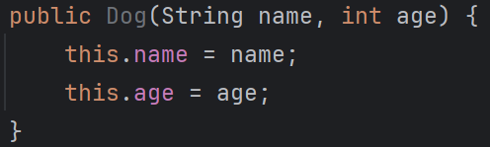

- The keyword “super” in a constructor will call the parent constructor.
- The keyword “this” will either assign a value, or call another constructor.

Method Overloading/Overriding

- Overloading - Methods with the same name, but a different number, type, or order of arguments as parameters. The example we've seen so far is with constructors. Same names, but different amounts of arguments (no-args, all-args, some-args)
- Overriding - A child Class will implement the same method signature as a parent Class, but the body of the method (the code inside the method) will be different. In other words, the child OVERRIDES the functionality of the parent.

- Method overloading and overriding are two examples of Polymorphism, which is a pillar of OOP.

Strings
- Strings are groups of characters (specifically chars). Because words and sentences etc are so often used in programming, Java defined a String Class with particular functionality to support their use in development.
  - Strings are objects not primitives. There’s an entire String class, which we make String objects from.
    - The String class has the final non-access modifier, which means that you can’t create subclasses of String.
  - Strings are actually char arrays under the hood.

- Strings are immutable. Once a String object is created, its value cannot be changed.
  - We can assign a String variable to a new String value, but this won’t change the value of the original String.
  - We can also use String methods to create a new String from an existing one, but again, the original String will remain unchanged.
- Strings use the .equals() method to compare equality between two Strings.
  - Why shouldn’t we use == to compare Strings (or any objects)?
    - == compares the values of primitives, but the memory address of objects. This isn’t very helpful for comparing object values.
    - .equals() on the other hand, will compare the actual values of the objects. Which is why we use it for Strings and ALL other objects.

- A bit of a deeper look at String equality: Strings override the .equals() method from the Object class (read about the Object class below) to test the order and values of the chars contained in the String.
  - There is also a method called .equalsIgnoreCase() which... ignores casing.
- Strings can be constructed in a special way in Java source code. Just put characters between “two double quotes.” This will create a String object called a String literal. These String literals are stored in a place in heap memory called the String Pool.
  - Why?? Because we use Strings all the time! The devs made this shorthand way to make Strings, and also save memory.
    - It lets us skip the “new” keyword and the constructor call that we need to create every other kind of object.
  - Only one String object will be created for each unique String literal. So if multiple variables point to the same String literal, they will all technically point to the same object in the String Pool. This saves memory, with the side effect of Strings needing to be immutable.
    - Why do they need to be immutable? Imagine multiple different variables pointing to the same mutable (changeable) String object. Changing it for one variable would change it for all of the others too. That's bad.

  - Strings can be created with the new keyword too. Strings created like this will not be in the String pool, since they’re not String literals. They will just get thrown in the general heap, and get their own unique memory address.
I never do this BTW

- String methods (not a comprehensive list, just ones I find useful):
  - charAt(): Will find and return the char at the specific index given. Often used for finding the first letter in a String in control flow statements.
  - concat(): Joins two Strings together and returns the new String object.
    - But you can usually just use + to concatenate Strings
  - length(): simply returns an int with the length of the String.
  - split(): Takes a String and splits it into an array of substrings based on a delimiter you set. (commonly “,” or “ “). Returns all the new Strings in a String array.
  - trim(): removes whitespace from both ends of the String.
  - contains(): Checks to see if a certain sequence of characters exists in the String. Returns a boolean.
  - substring(x,y): extract the characters from a String beginning at the starting position (x) and to (but not including) the ending index (y). Returns those characters as String.
  - toLowerCase()/toUpperCase(): This will change all the characters that are letters to their lower or upper case forms.

- https://docs.oracle.com/javase/7/docs/api/java/lang/String.html
  - String Class documentation, read for all the info you could possibly want about Strings (such as all of the String methods)

StringBuilder (not on the curriculum, but useful)
- These are essentially mutable (changeable) Strings. StringBuilders are very similar to the String class, with built-in constructors that convert easily between themselves and Strings.
- Popular StringBuilder methods:
  - append(some string): adds chars to end of the current value
  - insert(some index, some value): adds chars to a specific location based on the given index
  - reverse(): reverses the characters in the value
- Generally, if I need to perform several mutations to a String, I’ll put it in a StringBuilder, perform the changes, and then create a new String out of the completed StringBuilder if I REALLY need the final output to be a String.
  - (Maybe I’m putting it in a method that takes a String specifically).

- There’s also another Class called StringBuffer, which is just like StringBuilder but it’s thread safe and synchronized. We won’t worry about this. Basically, multiple threads (processes) can access it at once without causing any data inconsistencies.
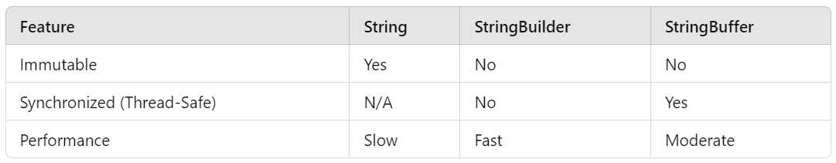

Interfaces and Abstract Classes
- Abstract classes and Interfaces are two Java entities that we can use to define a Class’s behaviors (methods), but not necessarily how to implement those behaviors.

- They both define abstract methods for Classes to override and implement. “Override and implement” means that the method will get changed and given a method body.
  - An abstract method is a method with no implementation (no method body). 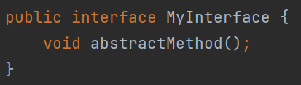
    - Note the semicolon at the end of the method instead of curly braces.

  - Abstract methods MUST be overridden by subclasses.
    - That’s why Abstract Classes and Interfaces are often referred to as “contracts”, because their Child Classes will be forced to override and implement every abstract method before the application can compile.

- They can both contain fields (variables).

Interfaces
- Interfaces contain only abstract methods (generally).
- A Class can implement multiple Interfaces (note - classes do not EXTEND interfaces, they IMPLEMENT interfaces).
  - This is Java’s way of allowing for functionality similar to multiple inheritance (which isn’t possible with plain old Classes). They are able to do this because they have strict rules preventing method/field call ambiguity.

- All interface fields are public static final by default
- Interfaces cannot contain constructors (Interfaces aren’t classes, so you can’t make objects out of them. Thus, no constructors.)

- All interface methods are abstract and public by default*
  - Since Java 8, interfaces are allowed to use the “default” keyword to declare concrete methods. This is for backward compatibility with a Java construct called lambdas. We won’t really do this unless absolutely necessary, you might as well just use an abstract class if you need some concrete functionality.

Abstract Classes
- Abstract classes contain abstract methods, but they can also contain concrete methods. (A concrete method is just a normal method. Fully implemented method body, like we’ve been seeing).
  - Again, abstract methods must be overridden by a subclass, while concrete methods will get inherited, but won’t need to be overridden.

- Abstract classes cannot be directly instantiated (you can’t make an object of them). They must be extended by a concrete (normal) class that overrides their abstract methods.
  - Because of this, abstract classes can not have the “final” non access modifier. (Since that makes Classes unextendable).

- A class can only extend one parent class. This includes abstract classes. This avoids conflict with methods with the same method signatures from multiple classes.
—----------------------------------------
- BIG DIFFERENCE: Classes implement interfaces and extend classes. Classes can implement multiple interfaces, but can only extend one class. Interfaces ARE NOT Classes.
  - Also, Interfaces extend other Interfaces.

- Why use one over the other? I would only use abstract classes if I NEED some concrete methods. Otherwise, I use interfaces most of the time, because they’re easier to write and I find them more flexible to use (multiple inheritance).
- So what’s the point of abstract methods? By laying out abstract methods in abstract classes/interfaces, we set a baseline of functionality that MUST be implemented by child classes.
  - This forces a certain set of functionalities for child Classes, while giving the developer the flexibility to define that functionality when creating the child Class. It also ensures that we can have multiple sibling classes that follow the same outline as their shared parent.

- Good demo video on abstract classes: https://www.youtube.com/watch?v=52frlN8webg
- Nice article on abstract classes vs Interfaces: https://stackoverflow.com/questions/18777989/how-should-i-have-explained-the-difference-between-an-interface-and-an-abstract

Variable Scopes
- The variable scopes define where a variable can be accessed from in the code.
- There are 4 scopes in Java:
  - Class (static) scope - static variables declared in a Class. The variable and its value is shared between all objects of that class. (static int i = 0);
    - A change in the value of a class scoped variable will be reflected in every object of the class.
  - Instance (object) scope - non static variables declared in a Class. The variable and its value is specific to the object it belongs to. (int i = 0);
    - A change in the value of non-static variables will only be reflected in that specific object.
  - Method scope - A variable declared in a method can only be accessed in that method. This includes parameters (arguments) given to the method.
  - Block scope - A variable declared inside a block of code (defined within curly braces) is only visible in that block. This includes if/blocks, loops, etc.
    - Method scope is essentially a specific form of block scope.

The “static” keyword
- The static keyword is one of the non-access modifiers. You’ve seen the static keyword in front of methods and variables before, for instance in your main method.
  - public static void main(String[] args) {}

- What does static do? - Static members (objects/variables/methods) belong to the class, as opposed to objects of the class. This means that every instance of a class will share the same value for static members.
  - For instance, if a class has public static int i = 5, every object will have an int called i equal to 5. If this value is changed to 6 in one object, it will change to 6 for every other object too.
    - If you want a value shared amongst every object, it should be static. If you want that value to be unique amongst objects, it should be nonstatic.
- Static methods cannot call non-static members.
  - Why? Non-static members belong to specific objects, while static members belong to the class itself. In other words, Non-static members belong to specific instances of the class.
    - You must instantiate an object of the class to access those object-scoped nonstatic members from within a static method. Just another one of Java’s rules

Errors and Exceptions (and the Throwable Class)
- When your application encounters a problem that stops it from completing its tasks, it will “throw” an error or an exception. This will cause your app to stop running if they aren’t handled appropriately. Errors and Exceptions are actual objects in Java!
- Errors are problems that the application can not reasonably be expected to recover from. You want to fix the error-causing code, instead of working around the error.
  - OutOfMemoryError - No more memory for Java to use
  - StackOverflowError - No more room on the stack for a new method call

- Exceptions are problems that the application can reasonably be expected to recover from. There are two main types of Exceptions - Checked and Unchecked.

Checked Exceptions (AKA Compile Time Exceptions)

- These are noticed by the compiler (the compiler CHECKS for them before you can run the application). You will be required to handle these exceptions before your app will compile successfully. (see below on how to handle exceptions). Examples include:
    - FileNotFoundException
    - ClassNotFoundException

Unchecked Exceptions (AKA Runtime Exceptions)

- The compiler does not notice these, hence unchecked - the compiler does not check for them, instead they get noticed at runtime.
    - Generally, these are problems in the logic of the code that can be avoided by writing better code instead of handling them. Examples include:
      - ArithmeticException
      - ArrayIndexOutOfBounds
- All Exceptions and Errors inherit from the Class Throwable. Errors and Exceptions get thrown, which stops your code’s runtime.
  - Exceptions all inherit from Exception Class; Errors all inherit from the Error Class
  - RuntimeException is the parent of all unchecked exceptions. Any other Exception including Exception itself is considered to be a checked exception.
- 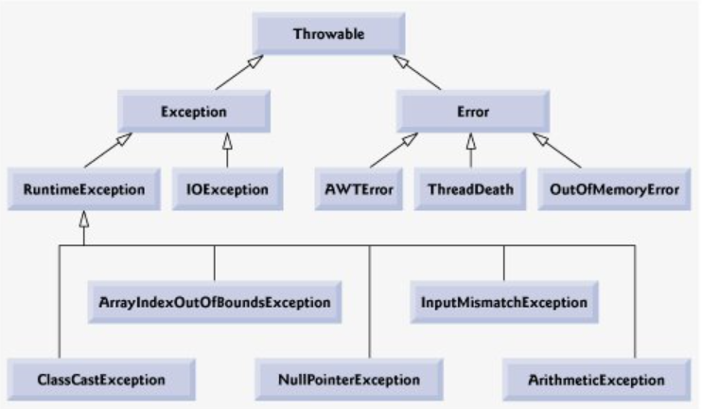
- List of all Java Exceptions: https://programming.guide/java/list-of-java-exceptions.html

Ok so how do I actually handle exceptions? Try catch blocks!!
- Try/catch blocks are the way Exceptions are caught and managed instead of letting the app crash. Technically, you can handle Errors with this too, but it’s horrible practice so don’t do it.
  - Try Block - Contains the code that you want to run that MAY result in an Exception being thrown.
  - Catch Block (at least 1 is required, but you can have multiple) - States the exception type that it can catch, then provides code to run when/if the Exception occurs. Note that the moment the try block encounters the thrown Exception, no more code from the try block will run. It will go straight to the catch.
  - Finally Block - This block of code will run after the try block completes OR after the catch block, whichever is appropriate. These aren’t required but it’s good for resource cleanup or if you want any specific thing to happen at the end of the try/catch

- “throws” vs “throw”
  - “throw” will create an Exception or Error object and cause it to proceed down the stack (down to the previous method calls).
  - “throws” is another way to handle Exceptions.
    - This indicates that a method could throw an Exception, but you want a method further down the stack to resolve it. This only has real functionality with Checked Exceptions, since your code won’t compile otherwise. This is technically the “other” way to handle exceptions, but it’s more like you’re throwing it to be handled elsewhere (or eventually crash your main method)
- You can also make custom exceptions, in case there’s a problem that can occur in your application that isn’t matched by any of the built-ins.
  - All you have to do is write a new class that extends Exception or UncheckedException, depending on which behavior you want it to have.
  - Typically you won’t make custom Errors

The Collections Framework
- “A Collection is an object in the family of Iterables that we can use to contain and manipulate a group of objects.”
  - So basically they’re a bunch of different Java data types that store and manage sequences of data in different ways.
- Collections are similar to Arrays, but they only store objects, and have a wider set of functionalities. They’re generally more flexible than Arrays.
  - For example, Arrays cannot grow or shrink in size while Collections can change size. This is the concept of static sizing vs dynamic sizing.

- Every Collection inherits from the Collection Interface, which extends the Iterable Interface. (See the diagram below)
  - There is also a Collections Class which has a bunch of static methods that all types of Collections can use.
  - You can think of The Collections API like a family tree of Interfaces and Classes related to the Iterable and Collection Interfaces.

- Shared behavior of collections includes size flexibility, and inheritance from the Collections Interface. Most of them share methods like .add(), .remove(), and .size()
  - We’ll talk about Lists, Sets, Queues, Maps, and how they’re different. Note that these 4 are all Interfaces, with different subclasses we can instantiate.

Lists
- Order: Elements in a List are stored in order of insertion.
  - The first element to get inserted is at the front of the List (index 0).
  - We CAN reorder them, but it won’t happen without our intervention.
- Has an index (we can access the nth element using the .get() method).
  - Lists are zero indexed
- Can have duplicates and null values
- They are Iterators (each element can be accessed by looping through the List)
- Some List methods:
  - .add() -> put in a new element to the end, or a certain index
  - .get() -> select an element at a certain index
  - .set() -> overwrite an element at a certain index
  - .size() -> returns the number of elements as an int
  - .remove() -> remove an element at a given index
  - forEach() -> do an action for each List element

- Implementations of Lists (in other words, concrete Classes that implement List)
  - ArrayList -> uses an Array that can be sized dynamically.
    - Fast access to any element
    - Fast adds to the end
    - Slow inserts and deletes in the middle (compiler wise… this difference is negligible to us)
  - LinkedLists -> uses a series of nodes that point to the next node in the List
    - Fast inserts given that you have the adjacent node
    - Slow lookup for elements in the middle (since you have to go node by node to find what you’re looking for)
    - Also implements the Queue Interface
  - Stack and Vector
    - Two collections we’ll probably never use. They’re very similar to ArrayLists but:
      - Vectors are synchronized, making them “thread safe”. Something we’ll talk about in week 3.
      - Stack is a subclass of Vector that follows a LIFO (Last in First out) data structure, only letting you take elements off the top (like the Stack in Java memory).
Sets
- Like a set in math (a collection of unique, unordered objects)
  - Unique means no duplicate values
  - No particular order (not indexed) so we can’t iterate through them without using .iterator()
  - One Null element max (since there are no duplicates)
- Methods
  - Intersection -> returns common elements of two sets
    - set1.retainAll(set2); //this would leave set1 with only the elements found in both sets
  - Union -> combination of two sets (no duplicates)
    - set1.addAll(set2); //this would leave set1 with all elements from both sets
  - Difference -> opposite of a Union
    - set1.removeAll(set2); //this would leave set1 with only the elements found in set1 but not set2
  - .iterator() -> returns an Iterator with the same elements as the Set.
    - ITERATORS HAVE INDEXES which is why one may choose to do this
      - We can use the .hasNext() and .next() methods to iterate through an Iterator
  - .add()
  - .remove() -> pass in the object you want to remove from the set
  - .size()
  - .contains() - returns a boolean of true if the object given is contained in the Set
- Implementations
  - HashSet -> typical general use Set. All the same attributes as stated above
  - TreeSet -> ordered set, lets you get elements in their natural order
    - Natural order? Alphabetical for letters or least->greatest for numbers.
      - How does natural order work for objects?
        - Comparable/Comparator to define that

Queues
- Queues are meant to store data that get stored in order of insertion, while only the element in front can get accessed or removed.
  - FIFO: First In, First Out - The first element in a queue will be the first element to get removed.
- Like waiting in line (In many other countries, “lines” are called “queues”)
  - Thus, queues are ordered and can have duplicates, but you can only touch the elements in the first index.
    - In a queue, you can only manipulate the first element in line.
  - Most queues don’t let you insert nulls. But some do (Like LinkedLists)
- Methods
  - .peek() -> selects (views) the first element
  - .poll() -> gets and removes the first element
  - .add() -> add an element to the end of the queue
  - .remove() -> only in LinkedList (since it implements List)
  - .size() -> returns the size as an int
- Implementations
  - LinkedList (see above)
  - PriorityQueue -> Elements have priorities that can be set, an element with high priority is served sooner.

Maps (the oddball of the group - not actually a Collection)
- Unique Key/Value pairs
  - Keys can’t be null
  - Keys must refer to a value
  - Values can be anything (as long as it’s the datatype you specified when making the Map)

- NOT iterable like the others
- NOT part of the Collections Framework
- Lookup/Delete is super fast
- Slow to loop through (since it’s not Iterable)
- Methods
  - .put (key k, value v) -> add elements
  - .remove (key k, value v) -> remove element
  - .clear() -> remove all elements
  - .containsKey -> return true if the key is present
  - .containsValue -> return true is the value is present
  - .keyset() -> returns a set of the keys
- Implementations
  - HashTable - no order to keys, no nulls
  - HashMap - no order to keys, one null key, any null values
  - TreeMap - has ordered keys (natural order)

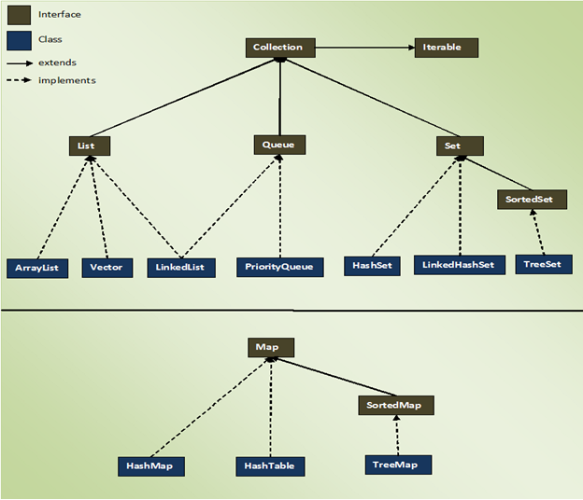
*If you understand this diagram, that’s half the battle. The other half is actually knowing when to use them. Some problems can be solved with any collection, and it’s up to you which one is best. You can hammer in a nail with a screwdriver, but is that the best option?
https://www.reddit.com/r/learnjava/comments/8u5pyx/having_trouble_understanding_collection_framework/
^^^good metaphor about the Collections framework

Know these differences between the different collections
- Does the collection allow duplicates?
- Does the collection allow nulls?
- Does the collection maintain an order of its values? Indexes?
- Does the collection have any rules regarding element access/removal?
- Why aren’t Maps considered collections?

Why Collections vs Arrays?
- Collections can do a lot more than Arrays.
  - The best example is dynamic size. Arrays can’t change size, but Collections can.
  - Collections generally have more methods than Arrays.
  - Collections consume less memory than Arrays (generally, not always)

- One reason to use Arrays is performance.
  - Collections only store objects, so when we use a primitive in a Collection, it has to get wrapped into the object version of those primitive (wrapper classes)
  - They work a bit faster too, but this difference is negligible for the scale of the applications we’re developing.

Wrapper Classes
- Wrapper classes let you treat primitives as objects. More specifically, they are the Class versions of your primitive types. Remember, primitives are NOT considered objects, thus they do not have a class associated with them.
  - Eg. int -> Integer, boolean -> Boolean, char -> Character

- This is necessary when you NEED to use objects, and primitives aren’t allowed. We see this when we use Collections, because collections only take objects (so we’ll have to use the Integer class instead of int, etc.)
- Boxing is the process of converting primitives into their wrapper class variants.
  - Java has a convenient feature called autoboxing, which does this process for you.
  - Similarly, Java ALSO has a feature called autounboxing, which does the opposite (turns a wrapper class into a primitive)
    - Java does this conversion for you. In other words, I never think about autoboxing/unboxing because it always happens under the hood. You should just know that it IS happening.

Generics
- Generics, denoted with <angle brackets>, allow for code that can handle multiple data types, depending on what the developer needs.
  - It’s another way of achieving polymorphism in java
- A generic is like a parameter that lets us choose the type of the data an object will use when instantiated.
Generics take two forms in a codebase:

1) When writing code that will be provided with value when used

2) When actually providing the value
- Generics only work with reference variables (one of the major reasons for the invention of the wrapper classes)
- When we instantiate an ArrayList, we say ArrayList<Datatype>. The actual ArrayList class declares it as ArrayList<E>. This lets us instantiate ArrayLists that hold any type of object when we create it.
ArrayList of Integers? Strings? Doubles? Pokemon? We can do whatever we want, thanks to the Java devs developing the ArrayList Class with a generic for the sake of flexibility.

SELF STUDY TOPICS------- (Curriculum topics etc. that are easy to read on your own)

- Always feel free to ask me questions on these topics. Even if I don’t talk about them during work hours, you can still ask me questions about them!
  - *If we have time/energy to chat about these during work hours we will of course.

Memory in Java - Stack vs Heap
- Java splits its memory allocation into two structures: The stack and the heap.
- The stack manages application/method flow. Methods that get called at runtime are placed on “top” the stack. It’s a Stack of methods, each running their processes.
  - If a method is called, that method gets placed on top of the stack.
  - If a method completes, it gets taken off the stack so that the other methods below it in the stack can complete as well.
  - LIFO - Last In First Out. The latest method that gets placed on the stack MUST execute and complete before the methods below it can.
    - The main method will be at the bottom of the stack at all times. The main method is where the application starts from.
      - Thus, the main method is always the first to start, and the last to complete.

- The heap is where objects are stored in memory. All objects are stored in no particular order in a “heap” of memory addresses.
  - Whenever we instantiate an object with the “new” keyword, it gets added to the heap.
    - When we use reference variables, it “refers” to some object stored in the heap (this is what a memory address is – the address of the object in heap memory)
  - Also read about the String Pool, it’s a special corner of the heap for Strings.

- The heap stores objects and their variables, while the stack stores method calls and the primitives/reference variables in that method call.
  - Reference variables (variables that reference objects) in the stack point to the memory location of an object in the heap.

- Analogies that helped me learn stack/heap use cases -
  - Think of the stack as an organized line of methods executing and completing. Like a plate of pancakes that must get eaten in top-down order.
  - Think of the heap as a pile of objects in no particular order. Such as a pile of laundry that you tell yourself you will fold.

Garbage Collection
- Java’s memory management is abstracted away from us. (This basically means it’s hidden from us). It is responsible for processes that run in the background to manage memory while your application runs. It will remove objects from memory that no longer have any reference variable pointing to them.
  - We call this garbage collection!

- You can NOT force garbage collection. You can suggest that GC runs with System.gc(), but there is no guarantee that it will.

- The garbage collector calls the finalize() method to aid in garbage collecting an object. We never call this ourselves, it's simply the method that gets called when collection happens.

Car c = new Car(); //not eligible for garbage collection. It has reference variable c pointing to it
c = null; //now the garbage collector can remove the new Car object from memory
c = new Bugatti(); //c is now equal to a different object in memory, but Car can still be collected

Main point: if an object no longer has any variable pointing to it, it can be garbage collected. So despite us reassigning c, that initial Car object will never be able to be referenced again.

- What is the point of the garbage collector? Performance enhancement and memory management. If we have an object floating around with no way to reference it, there’s no point in taking up heap memory. At runtime, the garbage collector is always checking for objects that can be collected.

Java.lang and the Object Class
- The package java.lang is a built-in library in the JRE that is implicitly imported by the compiler. This is where all the most basic Java features lie. This includes the Object class, the Math class, the String Class, Arrays, amongst other things.

- The Object Class (from java.lang.Object) is the parent class of all classes. Because of this, every single Class actually extends from Object somehow.
  - Every Java Object IS an Object (by this I mean every Object in Java inherits from the Object Class, directly or indirectly).
    - For instance, we’ll often see our Class override methods from the Object Class such as constructors, hashcode(), equals(), toString().

BOILERPLATE CODE CHEAT SHEET
- For this cheat sheet, assume we have a Class called User, with three private variables

public class User {
private String name;
private int age;
private String favColor;
}

- What is boilerplate code again? Basically, it’s any piece of code that is written repetitively with little variation. We typically see this in our Model Classes.
  - In fact, they are repeated so much that intellij lets us right click -> generate boilerplate code such as...

- Constructors: Special methods that let us construct new objects by giving values to their variables. In other words, we use them to define the ways we can create new objects of a certain Class.
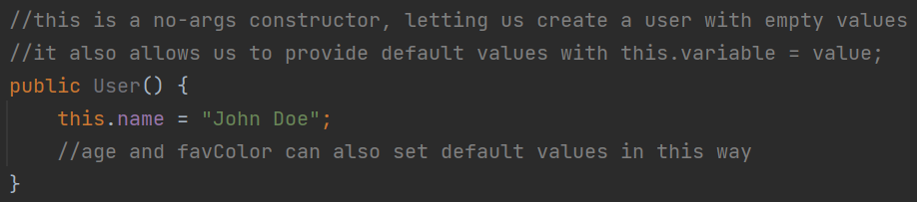
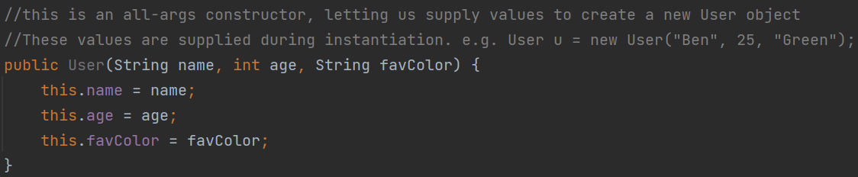

- A word you’ll hear often is “instantiate”. We use constructors to “instantiate” new objects based on some class.
  - User u = new User(); - instantiation with no args constructor
  - User u = new User(“Jamie”, 24, “Blue”); - instantiation with all args constructor
- You can also do “some-args” constructors, which we’ll use occasionally as we progress.

- Getters and Setters: Special methods that let us get and set values of private variables. In other words, we use them to access (get) and change (set) these values.
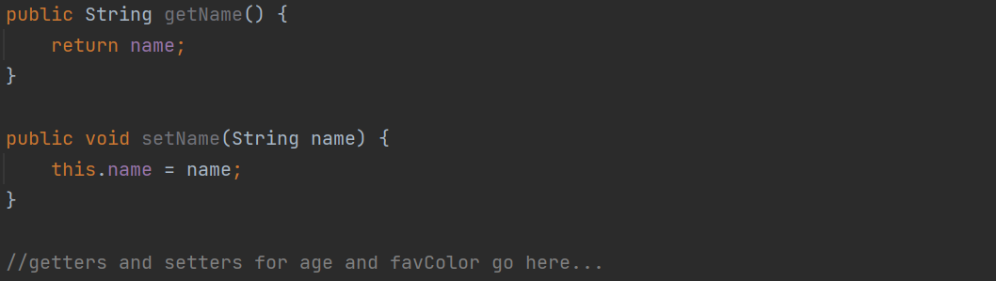
- We typically want our model classes to have private variables for the sake of encapsulation. We shouldn’t be able to use those variables outside of their defining class without getters and setters!
  - Remember – Encapsulation = private variables with getters and setters.

- toString: a special method that lets us print out the Class and its variables in a String format. Otherwise you’d just get a memory address when you try to print an object!

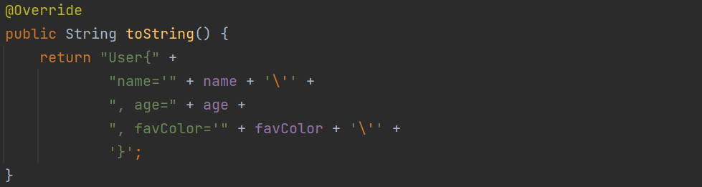

  - Trying to print a User object without toString:
    - models.User@2133c8f8
  - Trying to print a user with toString:
    - User{name='John Doe', age=25, favColor=’burlywood’}

- hashcode and equals: two special methods that let us compare objects.
  - Recall how we use .equals() when comparing objects. We can override that functionality in our own model classes. I don’t expect us to need these too often but I want you to be aware of them, especially .equals().
    - hashCode lets us define how to determine equality between objects, while equals performs the actual equality check.

    - 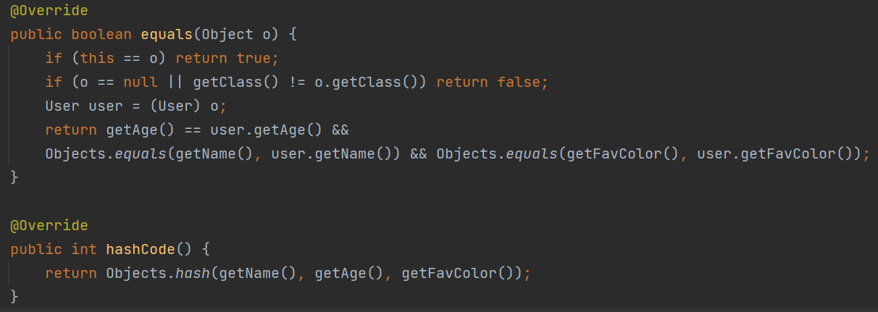
    - Again, please don’t get into the habit of writing boilerplate code manually.
      - Right click -> generate is your best friend in Intellij!

